**Antipodes 2023 Sydney to Auckland Yacht Race**

**7th – 12th October 2023**

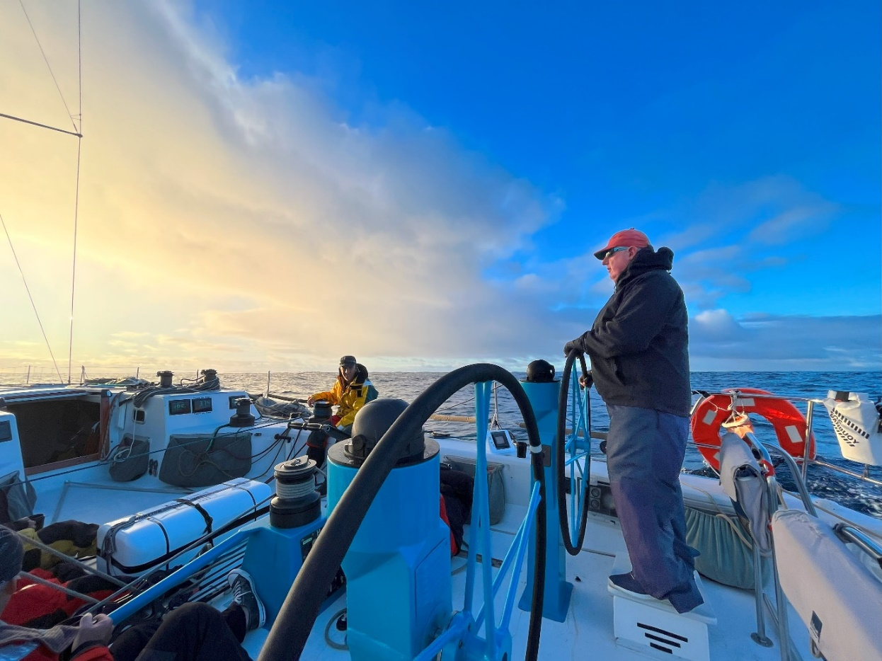

**Log**

Saturday 7th October 2023

**1300** Start slightly North of Sow & Pigs. Red channel marker used for timed runs. Not the best start but safe. FM, J2 & GS.

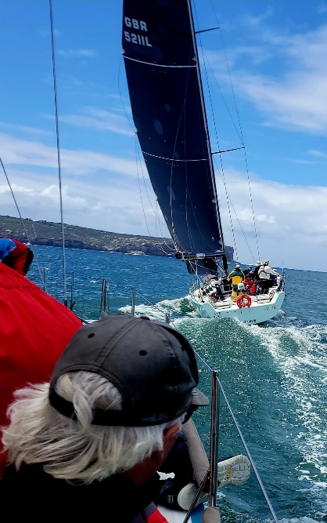

**1305** Hallam has massive 4 x o’boy on stbd runner.

**1310** East of North Head beacon. Stop boat, fix runner o’boy.

**1312** Hoist A4 & SS, GS down.

**1500** Barrenjoey Mark. J2 up, A4 down (Ralph had one after halyard was caught at mast exit), poor drop. Starting to head east.

Sunday 8th October 2023

**1830** Inboard runner block shackles rock down in chainplate and get caught. Runner block safeties around chainplate and not the shackle.

**2350** Code 0 deployed, J2 down, GS up.

Monday 9th October 2023

**0920** A3 & GS. Code 0 down. Tear in A3 notices at hoist. (repaired by Marky after halyard snap tea-bagging it).

**1330** Red MH spin halyard snaps 500mm from clip. Tea-bags A3. A4 hoisted (about time for the peel anyway). Start looking for noted repair.

**1352** Marky repairs A3 hole noticed when hoisted.

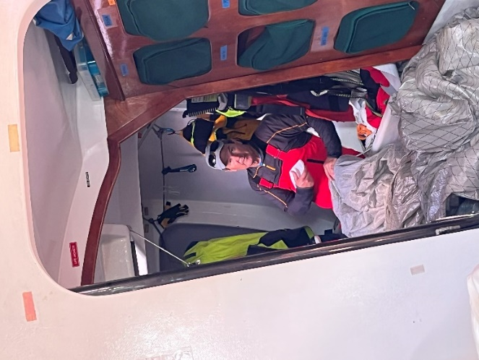

**1800** Peel A4 to A2 + SS.

**2200** A2 head ring parts and then A2 tea-bagged. Two tea-bags in one day. WOW. A6 hoisted. SS Down, GS up. Under wicked.

Tuesday 10th October 2023

**0100** Wind softens, sailing hotter angle. Expedition freezing when Tooltip shut down. Stop using Tooltip when left on.

**0700** J2 hoisted, A6 down, mainsail down. Send Damo aloft on main halyard to retrieve MH halyard.

**0735** Full Main.

**0740** A2 hoisted into 4kts wind. SS hoisted on standby.

**1130** Gybe onto port.

**1140**  Spot *Frantic* stbd aft quarter.

**1220** Disagreement with Camel driving about SS which was furled. Chat with Geoff about the situation.

**1245** SS deployed. Talk with Watch 2 about SS trimming.

**1320** Gybe onto stbd.

**1400** Talk through SS trimming with Watch 1.

**2000** A2 tack ring breaks. Take down line tied to coachroof. Pull in under boom. A4 hoisted.

**2020** Camel broaches with A4 & SS. SS furled. 16-18kts TWS on H5000 feels more like 20+kts. A4 better than A2.

**2110** Adjust TWS updraft calculation to read higher by 5%.

**2315** Green halyard snapped 300mm from clip and A4 tea-bagged. Third tea-bag for the race. SS deployed. A6 hoisted. SS down & GS hoisted. Potential tear in A4.

Wednesday 11th October 2023

**0745** Disappointing sked with Frantic 2NM ahead.

**1730** J2 hoisted, outboard sheet, A6 down.

**2130** Code 0 hoisted. J2 on deck, plugged in. Halfway from Cape Reigna to North Cape.

**2300** Abeam North Cape. J2 hoisted, Code 0 on deck plugged in.

Thursday 12th October 2023

**0310** Code 0 hoisted & GS, J2 on deck plugged in.

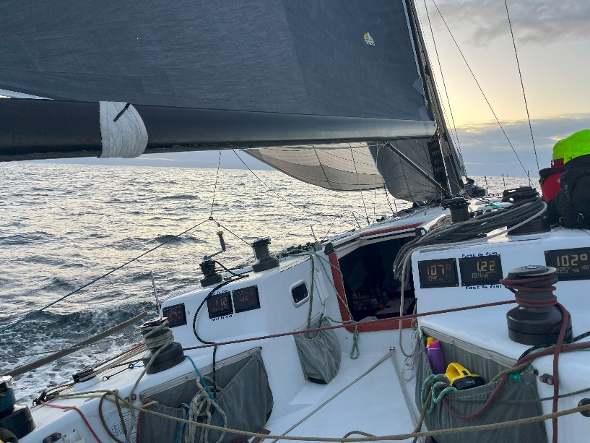

**0630** Cape Brett

**0645** J2 hoisted, Code 0 on deck and packed.

**1215 – 1225** J2 – J4 bare headed peel.

**1230** Reef 1. All went well. M1R & J4.

**1637** Finish.

